ITIL Service for Rainbow Cleaning Inc.

Anirudh Dutt

Illinois Institute of Technology

Abstract

In today’s competitive world, where the organizations are after their sales targets, an individual is hardly worried about maintaining and cleaning the offices, warehouses, or other working areas of that company. Maintaining and repairing are some evident keys for an organization to work smoothly without affecting the mundane. In the majority of cases, these organizations have their internal body of cleaning who are not adept enough to provide the proficient services. Even if they provide the adequate quality of service, they fail to understand every aspect that needs to be covered under their service. This stimulates the idea of outsourcing and creating a federated service which has ease of access and care.

In our project, we are analyzing the service strategies of Rainbow Cleaning Specialist Inc. which provides cleaning, maintaining, restoring, and repairing services. Rainbow Cleaning Specialist has expert janitors and high-quality equipment. Their goal is to offer cleaning on a schedule that will work for clients. It consists of web application which is the easiest way for customers to communicate and pursue to the services. Current goals of the company are—

* Creating a more accessible environment for customers.
* Bridging the gap between clients and company by incorporating IT services.
* Expand its services nationwide.
* Demand Management
* Increase profits

We are proposing a distinct ITIL service strategy to achieve Rainbow Inc. their goals. Our suggestions to attain those include—

* Introducing customers to wireless mobile services like Android/iOS application for ease of access.

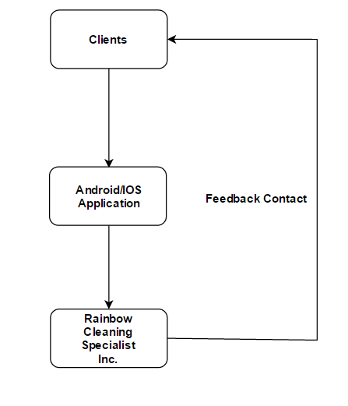

Figure: Basic flow chart for design of mobile application.

* Providing online chat so that clients can get on demand services.
* Nationwide services can be proliferated by creating awareness on social media like Facebook, twitter, LinkedIn.
* Cost analysis should be done at periodic intervals. Budgeting and Accounting aspects of Financial Management should be monitored. We are suggesting Rainbow Inc. implement optimized offers and estimates to customers.
* Have a one stop service.

Keywords: Financial Management, Demand Management, ITIL Service Strategy, Android

Acknowledgements

Mr. Ernest Swierk, CEO of Rainbow Cleaning Specialists Inc.

Ernest7254@gmail.com

References

Rainbow Cleaning Inc Website:

<https://rainbowpropertymaintenance.com/>

Authors:

Author 1: Zeshan Sayed

Author 2: Rohan Shirke

Author 3: Sreekumar Selvam

Author 4: Vaishnavi Gondane